## The University of Nottingham Logo PNG Transparent & SVG Vector - Freebie SupplyInformation Visualiztion Project (COMP3045)

## Project Proposal Report

## Omar Ismail (Student ID 20311657)

## 1st March 2023

## Data sources

I was going to use the IMHE GBD, but turns out that is an estimation of real mental phenomena statistics, and not actual diagnosis values, which renders it useless for our purposes, BUT it can be useful to compare diagnosis rates vs estimated real rates. The diagnosis rate is always lower because the IMHE fills in gaps when it comes to lower-income areas.

“Mental health disorders remain widely under-reported — in our section on [Data Quality & Definitions](https://ourworldindata.org/mental-health/#data-availability-on-mental-health) we discuss the challenges of dealing with this data. This is true across all countries, but particularly at lower incomes where data is scarcer, and there is less attention and treatment for mental health disorders. Figures presented in this entry should be taken as **estimates** of mental health disorder prevalence — they do not reflect diagnosis data (which would provide the global perspective on diagnosis, rather than actual prevalence differences), but are imputed from a combination of medical, epidemiological data, surveys and meta-regression modelling where raw data is unavailable. Further information can be found [here](https://ourworldindata.org/mental-health#how-is-prevalence-defined-and-measured).

It is also important to keep in mind that the uncertainty of the data on mental health is generally high so we should be cautious about interpreting changes over time and differences between countries.

The data shown in this entry demonstrate that mental health disorders are common everywhere. Improving awareness, recognition, support and treatment for this range of disorders should therefore be an essential focus for global health.” - [Mental Health - Our World in Data](https://ourworldindata.org/mental-health#prevalence-of-mental-health-and-substance-use-disorders)

Now, we collect data on depression from two sources. First, we have data on diagnoses made by doctors. In many countries, doctors inquire about people’s symptoms and how much they correspond to the criteria in the Diagnostic and Statistical Manual of Mental Disorders (DSM). They also use tests to rule out medical conditions, such as thyroid disorders, that result in similar symptoms. Second, we have data on the severity of depression. This data is collected from patients and the general population, using many different questionnaires and rating scales.[8](https://ourworldindata.org/mental-health#note-8) But there are still gaps in our knowledge. Data is lacking especially in many poorer places around the world. Even within high-income countries, people with poorer health or severe depression are much less likely to respond to these community surveys or report their symptoms accurately. If we didn’t take this into account, we would underestimate the prevalence of depression in the population.[9](https://ourworldindata.org/mental-health#note-9) - [Mental Health - Our World in Data](https://ourworldindata.org/mental-health#depression)

1. *a title*

Diagnosis vs. Reality: Mental Health in the Modern World

*a description of the problem & goals*

There is a feeling many people have that a considerable amount of modern mental health issue diagnoses are a reach. In other words, over-diagnosis. How come the previous generations did not have as many depressed people as we have today? Is it truly a rising problem, or is the system explaining away real problems by just diagnosing people as mentally ill?

According to [1][2][3][4], rates of depression diagnosis have risen x% since yz.

There are 3 explanations:

* People are more depressed than they were before
* Psychiatrists are haphazardly/blanket diagnosing people with mental illnesses.
* Mental illness is being used as a scapegoat/excuse for real world problems that people have (unemployment, bad health, weak relationships, addiction, etc…)

The project would compile data from multiple large sources, clean that data, and visualize trends in mental health diagnoses to detect any anomalies. And then overlap that data with other wellbeing metrics like:

* **Global GDP**
* **Income Inequality**
* **Lifetime expectancy**
* **HDI**
* **Poverty-adjusted life expectancy (PALE):** PALE is a measure of human development that combines life expectancy and poverty. It is calculated by subtracting the expected years of life spent in poverty from the overall life expectancy1.
* **Flourishing index:** The flourishing index assesses aspects of well-being such as health, happiness, meaning, relationships, and character2.
* **Social Progress Index (SPI):** The SPI measures the extent to which countries provide for the social and environmental needs of their citizens. It is based on three dimensions: basic human needs, foundations of well-being, and opportunity.

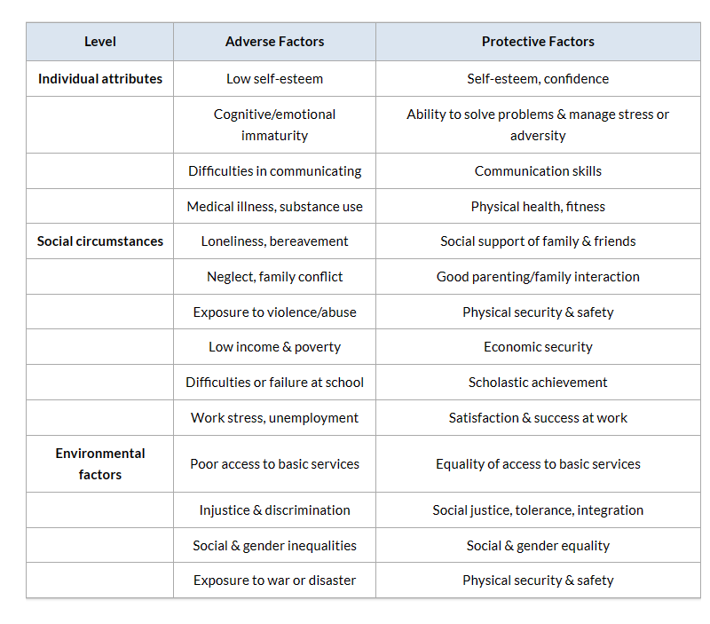Close to the WHO’s breakdown of risk factors for mental disorders.

**Comparison of IHME estimates to other sources**

He sees this form of doctor–patient relationship as one which leads to overdiagnosis and overtreatment. His motive for writing the book is to send a message that psychiatry is overstretched: ‘Instead of prescribing treatment for what Freud once called “normal human unhappiness”, we need to focus our efforts on patients who are seriously ill, and who need us the most. We do not need to diagnose the human condition’ (p. xiv) - <https://www.ncbi.nlm.nih.gov/pmc/articles/PMC6818431/>

The questions to answer:

(Hard numbers-based questions)

1. How many people are diagnosed with a mental disorder today? (Pictogram chart)
2. What is the prevalence of mental disorders over time? (https://ourworldindata.org/grapher/share-with-mental-and-substance-disorders?time=2019&country=~SAU)
3. How does the prevalence of mental disorders vary by age and gender? (<https://ourworldindata.org/grapher/share-with-mental-or-substance-disorders-by-sex?stackMode=relative&time=1990..1994&country=~OWID_WRL>, bar chart)
4. What is the relationship between mental disorders and wellness markers? (animated Line Plot)
5. Are there any changes in the public perception of mental disorders? (google trend searches overlapped over time, line plot, country breakdown)

(Investigative questions)

1. Are there any changes in the diagnostic criteria for mental disorders?
2. Are there any changes in the diagnostic tools used?
3. Are there any changes in the training of clinicians?
4. Are there any changes in the media coverage of mental disorders?

(Plot rise of mental health facilities like beds and centers and connect to rising expenditure in the sector)

1. Are there any incentives for clinicians to diagnose more patients with mental disorders?
2. Are there any changes in the pharmaceutical industry?
3. Are there any changes in the insurance industry?
4. *a description of the domain, task, dataset, users/audiences that you're targeting.*

The task is to compile data from multiple large sources, clean that data, and visualize trends in mental health diagnoses to detect any anomalies. And then overlap that data with other wellbeing metrics like wages, inflation, obesity rates, divorce rates, and fertility.

Find markers of wellbeing. Find evidence that this problem is a real problem (citations). Research to find possible solutions and combine them to create a final solution. Get good data from public sources.

The data sources picked are:

* **Google Trends – Gives you insight on the collective human psyche.**
* **Gapminder**
* **Human Development Data from the UN -** [**Data Center | Human Development Reports (undp.org)**](https://hdr.undp.org/data-center)
* **GHDx -** [**VizHub - GBD Results (healthdata.org)**](https://vizhub.healthdata.org/gbd-results/)
* [**Mental Health - Our World in Data**](https://ourworldindata.org/mental-health)
* [UNdata](https://data.un.org/)

The users we are targeting are aspiring psychiatrists and other medical professionals. If the data proves that mental health issues are truly rising, and that there are concrete causational factors causing this to happen, then decision makers and leaders will benefit from this project.

1. *your proposed infovis solution. You should propose initial designs of an infovis solution.*
2. *a brief justification/rationale on key implementation decisions.*

* Obviously the poster looks attractive, while still packing a large amount of data

1. *your proposed implementation approach: like which language and platform(s) you will use.*

Using R because of its powerful and easy to access tools. With some added libraries, it can basically create any data visualization needed, with the themes to fit. Photoshop/illustrator will be used to put together the final poster, because it provides a plethora of tools and has probably the most online support/learning content.

Resources:

[World mental health report: Transforming mental health for all (who.int)](https://www.who.int/publications/i/item/9789240049338)

[WHO MiNDbank - WHO European framework for action on mental health 2021–2025](https://extranet.who.int/mindbank/item/7513)

[WHO MiNDbank - WHO Comprehensive Mental Health Action Plan 2013-2030](https://extranet.who.int/mindbank/item/7510)

[About GBD | Institute for Health Metrics and Evaluation (healthdata.org)](https://www.healthdata.org/gbd/about)